**PIZZA SALES SQL QUERIES**

**1. Total Revenue:**

SELECT SUM(total_price) AS Total_Revenue FROM pizza_sales;

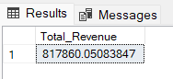

**2. Average Order Value**

SELECT (SUM(total_price) / COUNT(DISTINCT order_id)) AS Avg_order_Value FROM pizza_sales;

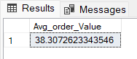

**3. Total Pizzas Sold**

SELECT SUM(quantity) AS Total_pizza_sold FROM pizza_sales;

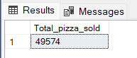

**4. Total Orders**

SELECT COUNT(DISTINCT order_id) AS Total_Orders FROM pizza_sales;

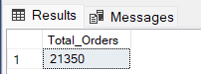

**5. Average Pizzas Per Order**

SELECT ROUND(SUM(quantity) * 1.0 / NULLIF(COUNT(DISTINCT order_id), 0), 2) AS Avg_Pizzas_per_order

FROM pizza_sales;

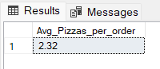

**B. Daily Trend for Total Orders**SELECT

DATENAME(WEEKDAY, order_date) AS order_day,

COUNT(DISTINCT order_id) AS total_orders

FROM

pizza_sales

GROUP BY

DATENAME(WEEKDAY, order_date);

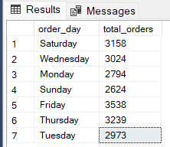

**C. Monthly Trend for Orders**

select DATENAME(MONTH, order_date) as Month_Name, COUNT(DISTINCT order_id) as Total_Orders

from pizza_sales

GROUP BY DATENAME(MONTH, order_date)

***Output***

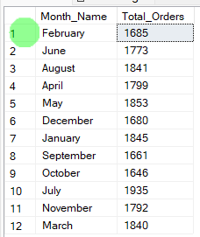

**D. % of Sales by Pizza Category**

SELECT

pizza_category,

ROUND(SUM(total_price), 2) AS total_revenue,

ROUND(SUM(total_price) * 100.0 / (SELECT SUM(total_price) FROM pizza_sales), 2) AS PCT

FROM

pizza_sales

GROUP BY

pizza_category;

***Output***

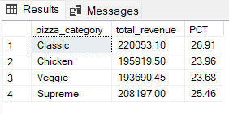

**E. % of Sales by Pizza Size**

SELECT

pizza_size,

ROUND(SUM(total_price), 2) AS total_revenue,

ROUND(SUM(total_price) * 100.0 /(SELECT SUM(total_price) FROM pizza_sales), 2) AS PCT

FROM

pizza_sales

GROUP BY

pizza_size

ORDER BY

pizza_size;

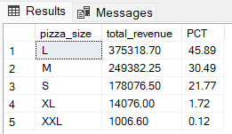

**F. Total Pizzas Sold by Pizza Category**

SELECT

pizza_category,

SUM(quantity) AS Total_Quantity_Sold

FROM

pizza_sales

WHERE

MONTH(order_date) = 2

GROUP BY

pizza_category

ORDER BY

Total_Quantity_Sold DESC;

***Output***

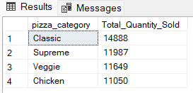

**G. Top 5 Pizzas by Revenue**

SELECT Top 5 pizza_name, SUM(total_price) AS Total_Revenue

FROM pizza_sales

GROUP BY pizza_name

ORDER BY Total_Revenue DESC

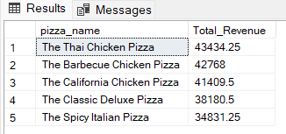

**H. Bottom 5 Pizzas by Revenue**

SELECT Top 5 pizza_name, SUM(total_price) AS Total_Revenue

FROM pizza_sales

GROUP BY pizza_name

ORDER BY Total_Revenue ASC;

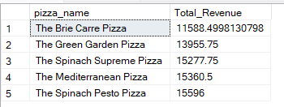

**I. Top 5 Pizzas by Quantity**

SELECT Top 5 pizza_name, SUM(quantity) AS Total_Pizza_Sold

FROM pizza_sales

GROUP BY pizza_name

ORDER BY Total_Pizza_Sold DESC;

***Output***

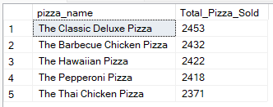

**J. Bottom 5 Pizzas by Quantity**

SELECT TOP 5 pizza_name, SUM(quantity) AS Total_Pizza_Sold

FROM pizza_sales

GROUP BY pizza_name

ORDER BY Total_Pizza_Sold ASC;

***Output***

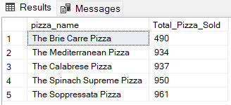

**K. Top 5 Pizzas by Total Orders**

SELECT Top 5 pizza_name, COUNT(DISTINCT order_id) AS Total_Orders

FROM pizza_sales

GROUP BY pizza_name

ORDER BY Total_Orders DESC;

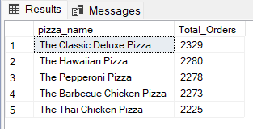

**L. Borrom 5 Pizzas by Total Orders**

SELECT Top 5 pizza_name, COUNT(DISTINCT order_id) AS Total_Orders

FROM pizza_sales

GROUP BY pizza_name

ORDER BY Total_Orders ASC

